**ASSIGNMENT 1 OUTPUTS 7/29/2022**

**Ineuron_pattern Output:**

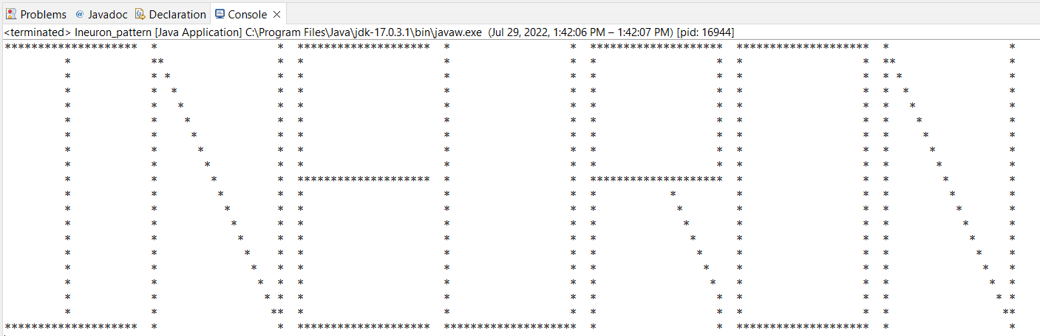

**Numbers_pattern_Output:**

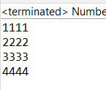

**WAP3_Output:**

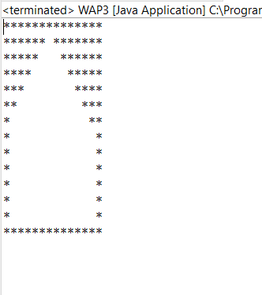

**WAP4_Output:**

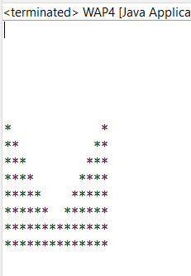

**WAP5_Output:**

